**CQL Command executions:**

**Creating a table in CQL console**

**Description of subset table created.**

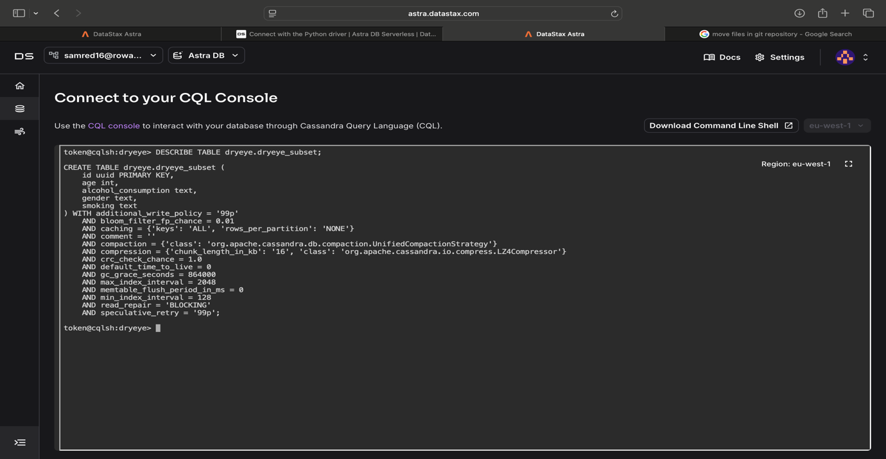

**Count of enries in subset table where Dry_Eye_Disesase=Y**

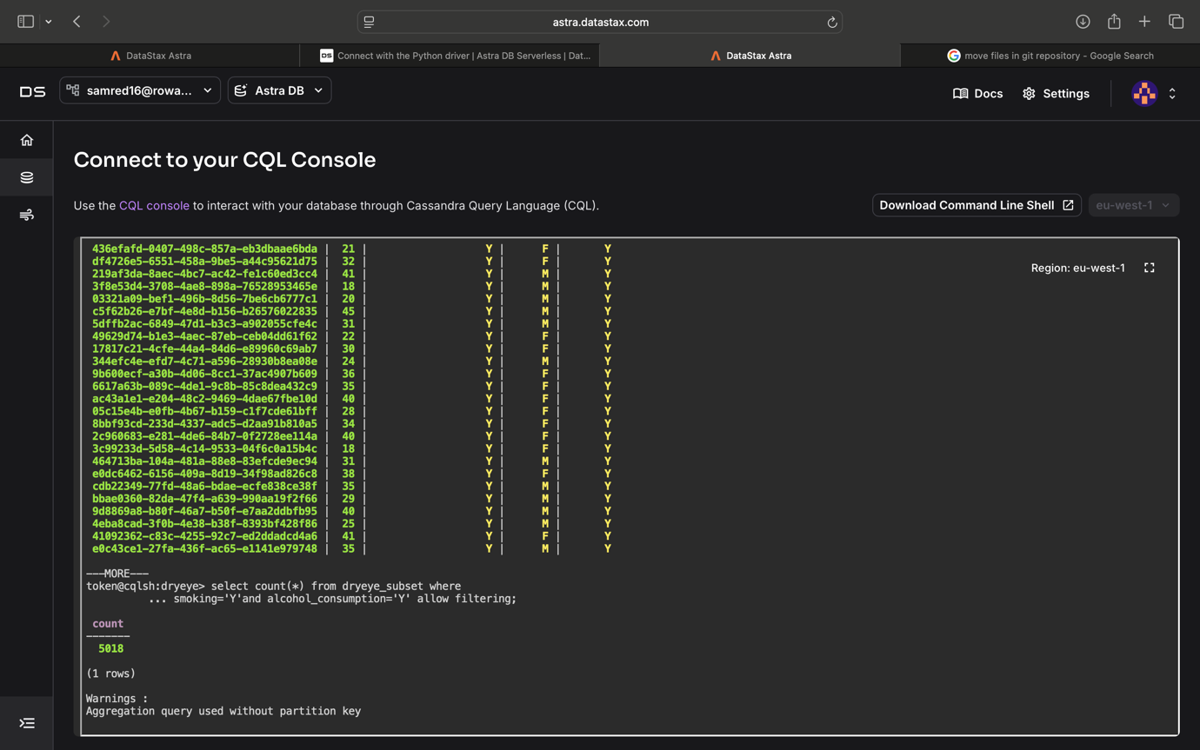

**Count of total entries in table**

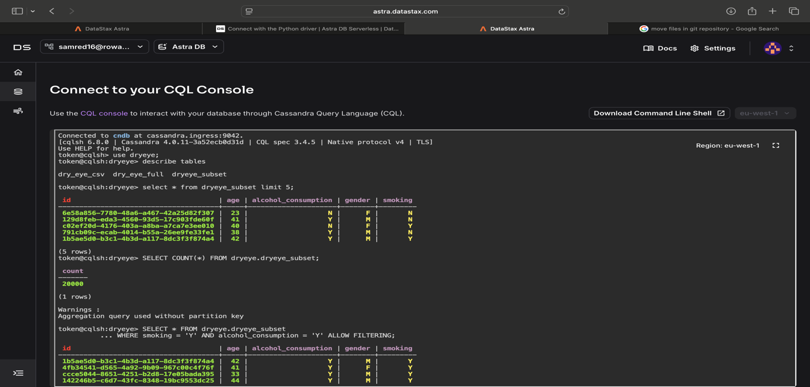

**Printing five entries from table**

